CSUWP: Writing. Online. A Work in Progress
by Bud Hunt (budtheteacher@gmail.com)

The Beginning:

I was not the guy who developed our first generation website. That credit goes to Will Allen, our first technology liaison, current technology liaison, and current webmaster. He and Cindy O'Donnell-Allen, our site's director, wanted our web presence to be a communicative space, breathable, if you will. CSUWP was a new site that year and from the start, the website was about providing places to share information and to be a place to that could reflect the ethos of the writing project site itself.

The original website contained a bulletin board and a chat room so that teachers could use the site with their students or with each other to stay in touch and be in conversation about the work of the site. In addition, that web site was built outside of the university’s web presence, using its own domain (http://csuwritingproject.org) at a time when it was not common to do so. The use of a unique domain accomplished a couple of important things:

- CSUWP had its own identity on the Internet independent from the university.
- The domain was easier and less complex than a URL nested within a larger university web site, meaning it was slightly easier to get to and remember.

(Note that moving from the University server is not necessarily a decision for all sites and should be considered in your own local context. It made sense for us. It might not for you.)

The Second Act:
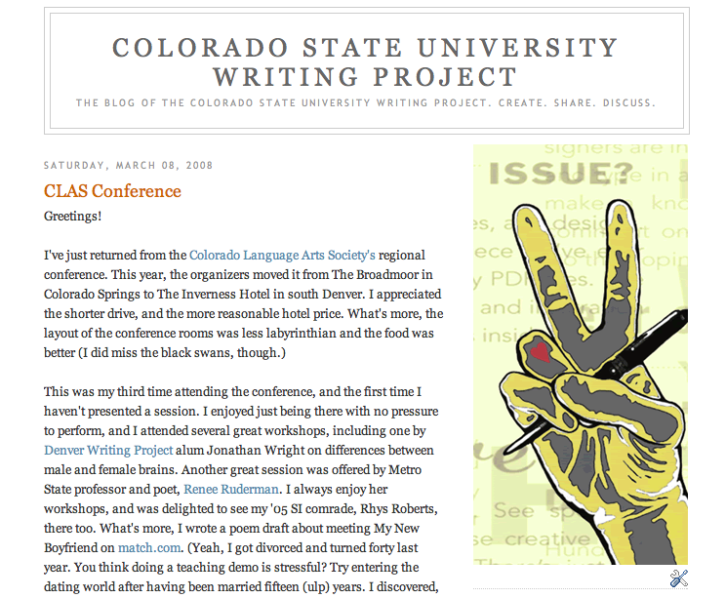
A year or so after the CSUWP site went live, I began blogging to support my thinking about inquiry and teaching. (http://budtheteacher.typepad.com). As a returning fellow to our second summer institute, I was interested in how we might use blogging and related technologies like podcasting to both document our work as well as showcase the writing that our teachers were doing. It was such good stuff – we didn't want it to not get seen/heard.
I created our site blog (http://csuwp.blogspot.com) and podcast feed using Blogger.com and Feedburner.com. We still use both of those tools now, almost two years later. Fellows stay in touch, share their experiences at conferences, post times that they'll be meeting for writing groups, etc. Because of the geographical distance of our site, it's nice to have one place where we can go to see what folks and the CSUWP are up to. Of course, if you’re keeping score on URL’s, you’ll recognize that we doubled up at that point.

As the blog began to flourish, spam became a problem for the website. That was coincidental, not related to the blog use, but the problems with spam on web forums pushed people to the blog as an interactive space for CSUWP conversation and resources. Eventually, when people started looking for the CSUWP website, people were finding our informal blog before our formal web site, due to Google’s search algorithms that privilege websites that are updated more frequently.
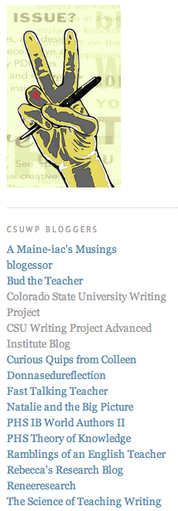
Currently, more than thirty of our site's participants are members with posting privileges on the CSUWP weblog – although fewer than ten of those have ever written to the blog. Along the way, many T-Cs were creating their own blogs as a piece of our post-institute workshop. Almost all of our teacher-consultants were creating blogs – but only ten percent of the blogs, at best, were remaining active. Interest was high, though, in technology and how to use the web as a publishing platform for writing, both with students and personally.

A Re-vision:


Our website soon linked to the blog, which became the regular source of updated content on the status of our programming, as well as our published work from program participants. Cindy and Will planned a re-design of our website to regain the idea of publishing and documenting what we were about. In late March, 2007, the new site went live (http://web.mac.com/csuwritingproject), this time using a .mac account as its “backbone” (ie. the program and service used to create it) in order to facilitate easy publishing of photos, videos, audio and the writing of our community. In addition, video and audio podcasts were posted to share and promote site work. The podcasts, produced as time allows, are slices of life of the CSUWP community, but require time and effort to make sure that content is added regularly (speaking to the need for a site to think systematically about content creation – who will create it, how often, etc. as part of a plan to consider dynamic site content).

As that website continues to grow, we're still using blogging to support our work. During our first Advanced Institute, we used blogs as we examined how technology can influence and support the work of teacher research (http://csuwpai.blogspot.com). That work spawned additional T-C blogs, and so, while the reach of CSUWP continues to grow online, it does so in a fragmented and ad-hoc way. Future work on our web presences might be as much about aggregating all of the content we have out there as well as working to ensure that the formal web presence reflects the work and roles of our WP site, as well as the informal “other work” we’re doing in other places on the Internet. That’s much easier to write here than it is to accomplish. We continue to learn.

